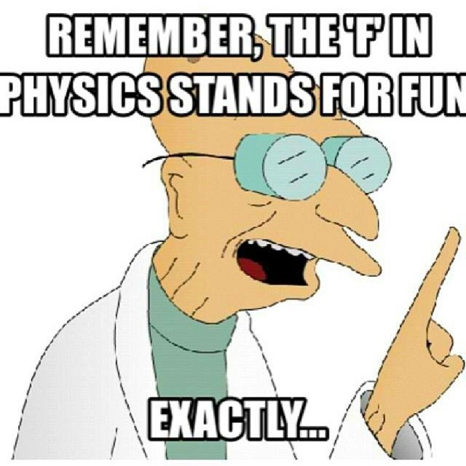
Guided Notes for Week 1 (Metric System)
What is Physics?
Physics is the study of ____________ and their interactions with ___________. Some of those topics include ______________, __________________, and _________________.

What you think the expectations are for two situations (you will be assigned them):
Situation One: _________________________
Expectation: ________________________________________________________________________________________________________________________________________________________________________________________________

Situation Two: _________________________
Expectation: ________________________________________________________________________________________________________________________________________________________________________________________________

Ms. Fioravanti & Mr. Snyder’s expectations in class:
- Entering the classroom
________________________________________________________________________________________________________________________________________________________________________________________________
- Homework
________________________________________________________________________________________________________________________________________________________________________________________________
- Needing something non-academic (bathroom, tissue, pencil sharpened)
________________________________________________________________________________________________________________________________________________________________________________________________
- Completing independent work
________________________________________________________________________________________________________________________________________________________________________________________________
- Completing partner work
________________________________________________________________________________________________________________________________________________________________________________________________
- Exit Tickets
________________________________________________________________________________________________________________________________________________________________________________________________
- Not understanding classwork after class
________________________________________________________________________________________________________________________________________________________________________________________________
- Absence
________________________________________________________________________________________________________________________________________________________________________________________________
- Lateness
________________________________________________________________________________________________________________________________________________________________________________________________

The metric system:
The metric system (or __________________________) is a system used by _______________ in the world. It works off of a ___________________. The system in America is called _________________ and is used by ________________. This works off a base whatever the hell we feel like system.

While using the metric system, __________________________________________________________. For ____________, ________________ is used. And for ____________, we use ___________________. Lasty, __________ is used for __________. (___________ measures __________________________________________.)

Independent Work:
Try to approximate the size of 1 g, 1 m, 1 L, and 1 second (1 s), using examples from your life.

Mr. Snyder & Ms. Fioravanti’s examples: (for reference)
1 g: ______________________________________________________
1 m: ______________________________________________________
1 L: ______________________________________________________
1 s: ______________________________________________________
Activity:
Using the meter stick, beaker, and electronic scales, you will be determining approximate sizes of different objects. These do not have to be exact, it is to get an approximation of how large some objects are. Before continuing, please go back and read the classroom expectations (we’ll know if you skipped this section if you’re not flipping your page back). There is a table on the next page to record your data.

 | Object | Size (with unit) | Conversion (Thursday only)
1
2
3
4
5
6
7
8
9
10

Prefixes: The metric system uses specific prefixes to denote ____________________________________. For example a ________________________________________________________. This is not useful if you’re going to measure something significantly larger or smaller. A _________________ represents ____________________. (______________).
Please fill in the left two columns of the table below now. Complete the right hand side for homework.
Prefix | Symbol | Size compared to base unit | Object for reference (meters) | Object for reference (grams)
nano |  |  | A molecule | Grain of pollen
micro
 |  | 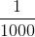
None (base unit) |  | 1
kilo
 |  |  |  | 7 blue whales
Converting between these is called ____________________________. This is very useful for converting between different units. For example, if I want to know how many kilograms are in 1000 grams.
To perform dimensional analysis, start with what we’re looking for.
(1)
Then write what we’re given.
(2)
We write the conversion next, writing the value you are given on the bottom, and the value you want on top.
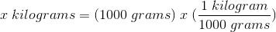 (3)
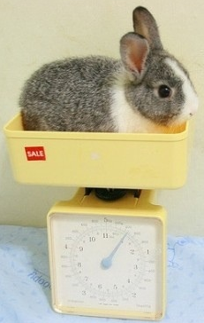
This step may be needed to be repeated several times (as shown in the next example.) (4)
Lastly, you have your answer.
(5)
1000 grams is the same 1 kilogram. (1 bunny)

Example #2. As a class, how many inches are in a mile?

Example #3. How many minutes are in 5 years? Please try to solve it yourself (in your notebook) before turning the page and seeing the answer.
If you do not understand or if you made a mistake (besides typing it in wrong), please ask your partner.
Independent Work: Use your answers from yesterday to perform dimensional analysis to convert the following:
- m to mm
- m to km
- mm to m
- mm to km
- g to ng
- g to Mg
- L to mL
Please use your notebook for workspace. You can repeat if you have more measurements, but all of these should be done.

Recap: Please explain with your partner how to perform dimensional analysis, in your own words.
________________________________________________________________________________________________________________________________________________________________________________________________________________________________________________________________________________________________________________________________________________________________________________________________

Precision and accuracy:
Precision: ___________________________________________________________________________. An example of this is __________________________________________________________________________________. You may not make the shot every time, but you are ____________________ in the same spot________________.
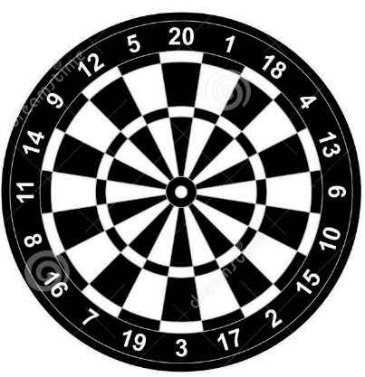
Accuracy: ___________________________________________ ______________________________. An example of this is throwing a dart. You may hit the __________ area every time, but you might not hit the _______________, which means you won’t be _________________.

Independent Work:
When would precision be more important?
________________________________________________________________________________________________________________________________________________________________________________________________
When would accuracy be more important?
________________________________________________________________________________________________________________________________________________________________________________________________
Is this accurate or precise (or both or neither)?
- You measure a sample as 0.5 g, 0.51 g, and 0.49 g. The actual measurement is 95 g. ____________________
- You measure a sample as 0.5 g, 0.51 g, and 0.49 g. The actual measurement is 0.5 g. ____________________
- You throw a ball at a target 30 meters away. You throw it 30 meters, then 27 meters, then 29 meters, then 25 meters. ______________
- You do your homework and get 1.2, 94, and 54.32 when you try the same exact question three times. The correct answer is 0.5. _____________________
Activity: You are about to receive a lab. While it is being set up, think about how you are going to act maturely and professionally.

Recap: Explain the difference between accuracy and precision. You may work with your partner(s) if you would like.
__________________________________________________________________________________________________________________________________________________________________________________________________________________________________________________________________________________________

Vocabulary (these should be defined in your notebook by the end of the week):
- Physics
- Metric system
- Imperial system
- Nano-
- Micro-
- Milli-
- Kilo-
- Mega-
- Base unit
- Gram
- Meter
- Liter
- Second
- Accuracy
- Precision

