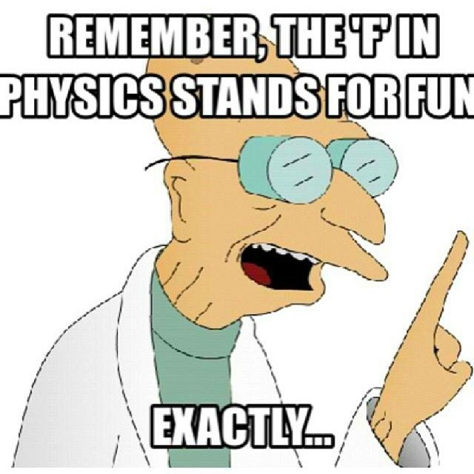
Guided Notes for Week 1 (Metric System)
What is Physics?
Physics is the study of ____________ and their interactions with ___________. Some of those topics include ______________, __________________, and _________________.

What you think the expectations are for two situations (you will be assigned them):
Situation One: _________________________
Expectation: ________________________________________________________________________________________________________________________________________________________________________________________________

Situation Two: _________________________
Expectation: ________________________________________________________________________________________________________________________________________________________________________________________________

Ms. Fioravanti & Mr. Snyder’s expectations in class:
- Entering the classroom
________________________________________________________________________________________________________________________________________________________________________________________________
- Homework
________________________________________________________________________________________________________________________________________________________________________________________________
- Needing something non-academic (bathroom, tissue, pencil sharpened)
________________________________________________________________________________________________________________________________________________________________________________________________
- Completing independent work
________________________________________________________________________________________________________________________________________________________________________________________________
- Completing partner work
________________________________________________________________________________________________________________________________________________________________________________________________
- Exit Tickets
________________________________________________________________________________________________________________________________________________________________________________________________
- Not understanding classwork after class
________________________________________________________________________________________________________________________________________________________________________________________________
- Absence
________________________________________________________________________________________________________________________________________________________________________________________________
- Lateness
________________________________________________________________________________________________________________________________________________________________________________________________

The metric system:
The metric system (or __________________________) is a system used by _______________ in the world. It works off of a ___________________. The system in America is called _________________ and is used by ________________. This works off a base whatever the hell we feel like system.

While using the metric system, __________________________________________________________. For ____________, ________________ is used. And for ____________, we use ___________________. Lasty, __________ is used for __________. (___________ measures __________________________________________.)

Independent Work:
Try to approximate the size of 1 g, 1 m, 1 L, and 1 second (1 s), using examples from your life.

Mr. Snyder & Ms. Fioravanti’s examples: (for reference)
1 g: ______________________________________________________
1 m: ______________________________________________________
1 L: ______________________________________________________
1 s: ______________________________________________________

Independent Work:
Which unit would you use to determine how much space an object takes up? ________________
Name an object that you would use to measure how long an object is. _______________________________
What are some units that we will never, ever use in this room? _______________________________ When would you use grams? (Do NOT say weight). _____________________________

Activity:
Using the meter stick, beaker, and electronic scales, you will be determining approximate sizes of different objects. These do not have to be exact, it is to get an approximation of how large some objects are. Before continuing, please go back and read the classroom expectations (we’ll know if you skipped this section if you’re not flipping your page back).

 | Object | Size (with unit)
1
2
3
4
5
6
7
8
9
10

Prefixes: The metric system uses specific prefixes to denote ____________________________________. For example a ________________________________________________________. This is not useful if you’re going to measure something significantly larger or smaller. A _________________ represents ____________________. (______________).
Please fill in the left two columns of the table below now. Complete the right hand side for homework.
Prefix | Symbol | Size compared to base unit | Object for reference (meters) | Object for reference (grams)
nano |  |  | A molecule | Grain of pollen
micro
 |  | 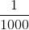
None (base unit) |  | 1
kilo
 |  |  |  | 7 blue whales

Reasonableness of answers:
Why do you think it is important that we check our answers?
________________________________________________________________________________________________________________________________________________________________________________________________

Do these values seem reasonable? Explain why or why not.
- Is 1 hour about the same as 0.05 seconds? ____________________________________________________
- Is 5 meters about the same as 0.005 millimeters? ______________________________________________
- Are 30,000 kg and 30 Mg about the same? ______________________________________________
- Should a car weigh 1 microgram or 1 megagram? ______________________________________________
Precision and accuracy:
Precision: ___________________________________________________________________________. An example of this is __________________________________________________________________________________. You may not make the shot every time, but you are ____________________ in the same spot________________.
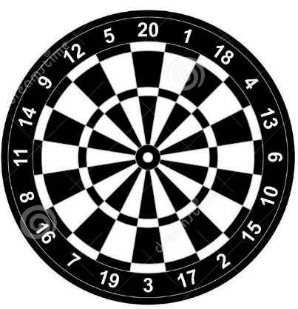
Accuracy: ___________________________________________ ______________________________. An example of this is throwing a dart. You may hit the __________ area every time, but you might not hit the _______________, which means you won’t be _________________.

Independent Work:
When would precision be more important?
________________________________________________________________________________________________________________________________________________________________________________________________
When would accuracy be more important?
________________________________________________________________________________________________________________________________________________________________________________________________
Is this accurate or precise (or both or neither)?
- You measure a sample as 0.5 g, 0.51 g, and 0.49 g. The actual measurement is 95 g. ____________________
- You measure a sample as 0.5 g, 0.51 g, and 0.49 g. The actual measurement is 0.5 g. ____________________
- You throw a ball at a target 30 meters away. You throw it 30 meters, then 27 meters, then 29 meters, then 25 meters. ______________
- You do your homework and get 1.2, 94, and 54.32 when you try the same exact question three times. The correct answer is 0.5. _____________________
Activity: You are about to receive a lab. While it is being set up, think about how you are going to act maturely and professionally.

Recap: Explain the difference between accuracy and precision. You may work with your partner(s) if you would like.
__________________________________________________________________________________________________________________________________________________________________________________________________________________________________________________________________________________________

Vocabulary (these should be defined in your notebook by the end of the week):
- Physics
- Metric system
- Imperial system
- Nano-
- Micro-
- Milli-
- Kilo-
- Mega-
- Base unit
- Gram
- Meter
- Liter
- Second
- Accuracy
- Precision

